**Notes: (View Before using excel file)**

**Resolution: 1920 x 1080**

**Zoom: On a 14 inch screen = 73% , On a 22 inch screen = 90/92%**

Spreadsheets and Dashboards

Table of Contents

1. Old Dashboard Evaluation 2

2. Specification and User Stories 3

3. House and Style 4

4. Highlighting Data 5

5. Sorting and Filtering data 6

6. Bullet Charts 7

7. Sparklines 8

8. The User Form 9

9. Form Validation 10

10. Testing the new Dashboard 11

# **Old Dashboard Evaluation**

Before we can evaluate a dashboard, we need to first understand what a Dashboard is. A Dashboard is a visualisation tool which provides awareness, trending, and both planning an actual comparison, frequently visualised in a slick simplified user interface. The dashboard should meet requirements set by the users and meet their expectations in terms of the kind of information provided.

In this regard, it is important for the dashboard to communicate information about positive and negative decision alternatives quickly, highlight factors that merit consideration, and show information in a non-linear format to facilitate its incorporation in decision making deliberations. (Evaluation of Effective Dashboards: Key Concepts and Criteria, n.d.)

*“ A dashboard is a visual display of the most important information needed to achieve one or more objectives that has been consolidated into a single computer screen so it can be monitored at a glace”*

*Steven Few, Information Dashboard Design ,p26*

The original dashboard showcased a number of mistakes, otherwise known as “The pitfalls of dashboards”, as mentioned by Stephen Few in 2006 in his book “Common Pitfalls in Dashboard Design”. The following are a few of the common pitfalls mentioned in his book.

* The original dashboard exceeded the boundaries of a single screen. By providing a fixed design size that matches the average user’s monitor , not only we save time from adjusting zoom and rations, but we also make clear the key information points of the dashboard, by making them fill a single screen in a pre-set format size that shows data clearly. Seeing too many data points may often blur the overall purpose of projecting information to the user by providing an overload of information that exceed screen limits and loses the focus of the user. It should be essential, as soon as the user views the dashboard, their eyes should be easy to focus on the most important area/issue
* Most data that is declared on a dashboard should provide the viewer with the right contextualisation when monitoring the business. Having random number figures and shapes without clearly showing what information they project it immediately rejects their purpose of providing simplified information, as the old dashboard did.
* Displaying excessive detail or precision. By illustrating an excessive amount of information (in addition to being out of context as mentioned before), it simply reduces the interest of the user to explore the dashboard and find answers they seek. The viewer has often limited time to waste on the dashboard, therefore only the most important information needs to be provided and be according to the user requirements (“User stories” as we will analyse further down this report).
* Choosing inappropriate display media. In the old dashboard we can see Rad-charts, Pie-charts, Arrows, pie-charts, all in unique designs and themes and all stacked on top of each other, without no clear context, it simply creates quite an informational disaster where information is not represented appropriately. Information is shown, but in such a bad way that makes no sense to they eye of the viewer.
* Using poorly designed display media. After selecting an appropriate means of media to present data, it also requires formatting it appropriately to make the message clear to the user. Simple bar charts or Radar-charts, clusters of tables, makes no use if not well formatted to match the needed message we try to present.
* Encoding quantitative data inaccurately. It is a logical manner that all tables and functions require some level of simple to complex encoding to properly manipulate data and display messages. Failing to do so results in illustration of wrong illustration tables that wrong messages or no messages at all (messages being the new information the user is trying to extract from the dashboard.).

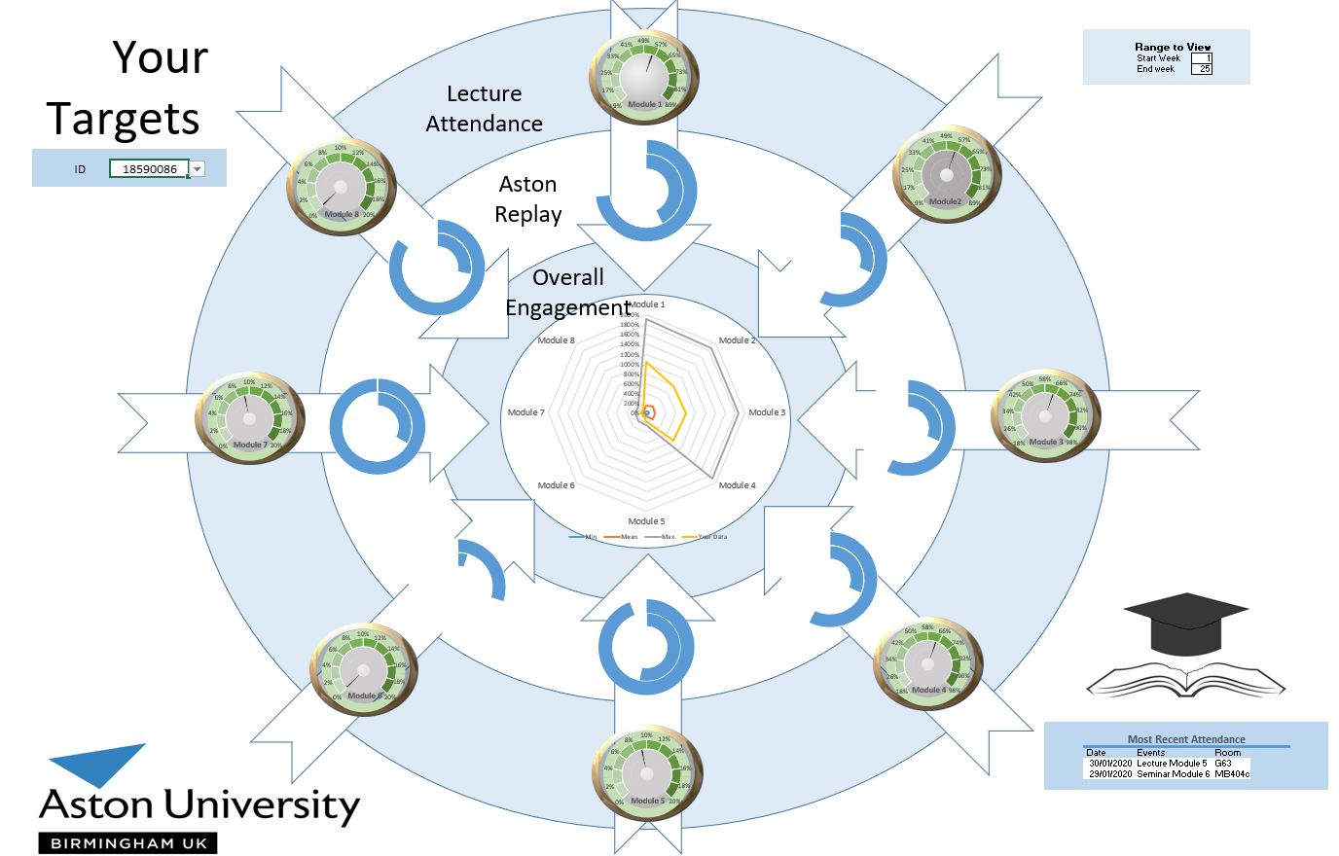The following is an image of the old Dashboard, with some of the pitfalls easy to be spotted as mentioned above.

Figure 1: Old Dashboard, "Quite a mess"

# **Specification and User Stories**

Every dashboard has a unique and specific user base, a group of people that will interact with it to extract wanted information. Therefore, it is important in every case to recognise what the user-base is and what are their needs and requirements from the dashboard. What they want to get out of it. For that purpose, we use User Stories; A list of requirements set by actual users, needed to base out structural process when making the dashboard and selecting what information It will show.

First, the new dashboard is made for university students, who wish to view academic information such as attendance, grades, module information etc. Their excel knowledge is average to good with frequent use for various assignments and academic works, therefore it is a required general knowledge for the average user.

The “Admin” control over the dashboard has the University itself. It is responsible for providing new raw data for each user variable, which will then be used to generate the tables/graphs/charts for the users to extract the information the need. Usually users are interested/limited only in information applying to themselves, whereas the University has access to information for everyone. In this dashboard information is more open and less restrict therefore everyone has access to every information; Further future work could improve this restriction process more thoroughly.

The purpose of the dashboard is to process raw information about students, provided by the university, and then project selective importation, which is required by the students, in the form of comparison, module information, general attendance etc. It can be used by individuals at any given time, with information most complete at the end of the academic year.

The appearance should be kept simple and consistent since we don’t want to confuse the user (Few, 2006). The dashboard was designed in a resolution of 1920x1080p, on a 14-inch monitor with a 75% zoom or a 22-inch monitor with a 95% zoom. The house-style was made to make use of available space to provide only important information, avoiding making the screen too crowded in an unpleasant way. The text-font was set as “Century Gothic “as it illustrated a more round-shaped text format, more clear to read, and font size set to 12, although some minor problems were presented by excel itself in terms of font size in places such as the drop-down list, where text is too small, but with no apparent fix. Use of colour was set to be as “light” and “friendly” as possible, with orange being the core colour of the dashboard, although a few steps were made to help student with colour-blindness, and some scale colours were set to a grey scale.

The inputs of the dashboard are simple and easy to use. Two simple drop down lists are all it requires from the user to set in order to view selective information , based on the selected values from the lists; One for the Student ID, with information for the selected student, and one for the module name, with information on specific modules (Note: All user students have the same 8 modules).

The outputs are tables and graphs illustrating informational reading list, Grade comparison Student-Class, Attendance comparison Student-Class and individual grades for each module analytically with class average in each case. Therefore, by selecting student ID eg.”1855939” and module “Business”, our tables will show information only for that student and that module.

The necessary raw data, needed to construct all those functions is information gathered by the university on every single student such as: module grades, monthly attendance, Comments made by course leaders, the reading list of every module, the grades of every student on every module, a list of the students themselves etc.

Some of the user stories needed to construct the dashboard are:

**Attendance**

1. Show my overall attendance for each module

2. I want to see my attendance in the library by the end of the year

3. I want to know the possible penalty, if any, from my attendance

**Performance / Pass-Fail / grades**

4. I want to see my grades(1st,2-1,2-2,3rd) for each module along with whether I passed or failed it

5. I want to know a percentage of the overall performance for each module given by the module leader

6. I want to see what comments the course leader gave, if any.

**Reading List**

7. Second year student, want dashboard to show a list of the books to read for each module

**Deadlines**

8. I want to see my upcoming coursework deadlines

9. I want to see my upcoming exam dates

**Blackboard**

**10.** I want to see how long/how much I’ve been using the Aston Blackboard (Monthly records for each student, with average)

# **House and Style**

Tufte talked about house and style of dashboard illustration in a concept called “Graphical Excellence”. It’s a well-designed presentation of data, effected by substance, statistics and design. It consists of complex ideas communicated with clarity, precision and efficiency. It also requires to be accurate and tell the truth.

“Graphical Excellence: Greatest number of ideas in the shortest time with the least ink in the smallest space” (Tufte, Graphical Integrity, 1983).

Few’s approach on a Well-designed dashboard was based on eloquence through simplicity. It is exceptionally well organised. Has condensed summaries. It has specific tasks at hand and is fairly customisable to the user. Can be conducted using small media that communicate the information in the clearest and most direct way possible.

The following the newly designed dashboard with explanation on design and style.

Based on Geralt’s Principles of Proximity, Things that are close to one another are perceived to be more related than things that are spaced farther apart. This can be seen above with the sparkline tables since they complete each other, or with the reading list and deadline tables, where both show information or the same module in this case.

Based on IBCS’s standards, we need to ensure we avoid clutter and content is organised. Therefore, all information is located inside various boxes of content, separated by small gaps to avoid over-crowding and making information more clear to the eye

Aston Label is located at the top right corner

The dashboard is visually and size-wise, at its full potential when we hide the tool ribbon

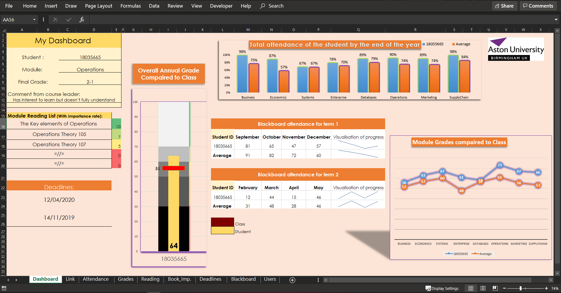

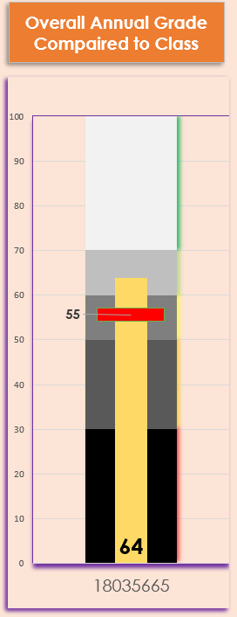

The bullet-chart is meant to show the background gray scale as the fixed grade scale of “1st”, “2-2”, “2-2” etc, and compare it to the progress of the whole class (red line) and the individual student we view information for ( yellow column bar) . Class grade is set as a small horizontal bar to appear as a landmark for the yellow bar. The goal the student could reach and exceed , getting a mark above average. Average grade can often move slightly but individual grades can vary , therefore the yellow line is the one covering the vertical distance in the graph in between the grey scales of “grade land-marks”.

The scale was made in grey scale to assist students with partial colour vision according to Few.

The User Form , which serve a perpuse of a “welcome form” since it opens whenever we open the excel file, is set to let the user chose the user ID they wise to log in with. In future updates, passwords would be set along ID’s for restricting access to only the information of the student who logged in with his student ID. It has simple formal with light colours to be visually appealing and simple to use. The theme of th UF is consistent with the edashboard’s

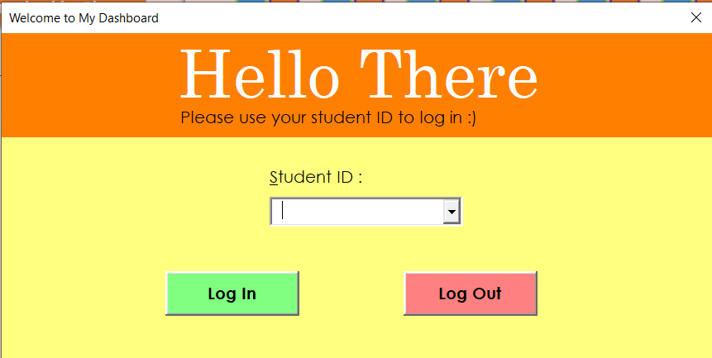

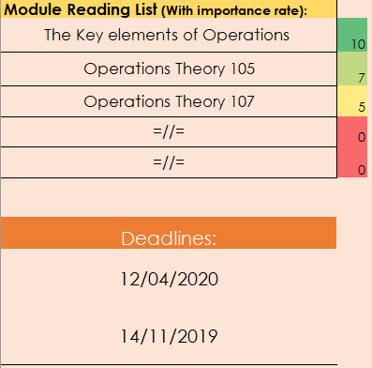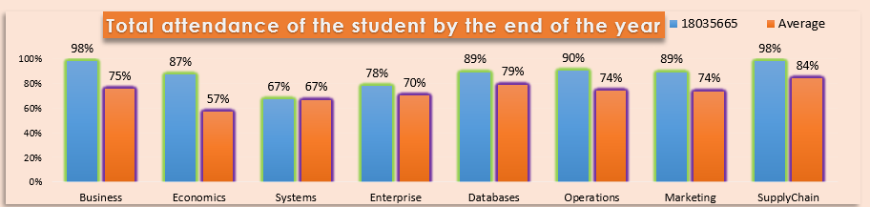

These two tables follow Gestalt’s Principle of proximity, where things close to one another are perceived related. In this case since information from both tables is referring to the same value, Module, They are related .therefore are placed close to each other, at the corner of the dashboard, forming their own little hypothetical box of content . Table at the top, also shows a colour scale of each book based on their importance, from red(low)to green(high) to emphasize the message.

Based on Gestalt’s principle of Similarity, things that have similar attributs(shape, colour) are perceived to be more related than things that are dissimilar. And that is what we see in the table below. Blue bars represent the selected student’s attendance for each individual module whereas the orange bars are the average of the class for each module respectively. The key message of the graph are not the numbers themselves, but the visual idea of how the student compared to the class in every module in terms of attendance .

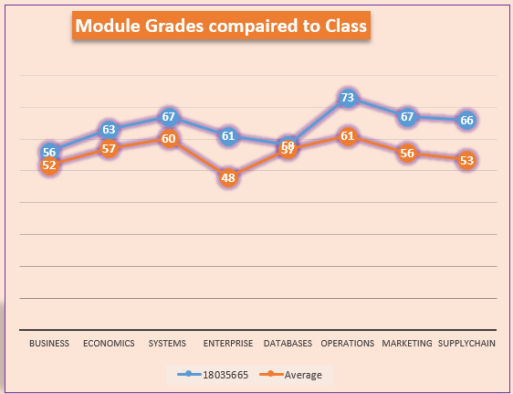

The line graph is used to compare the module grades of the selected student, to the average of the class for each module. Placing the legend close to the data we follow Gestalt’s principle of proximity to make clear the relation of each line to their meaning using colours (principle of similarity)

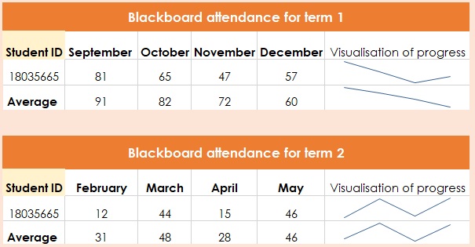

Sparklines are all dynamic so that the user can quickly evaluate information (in this case Blackboard use) according to Eckerson. Based on Gestalt’s principle of proximity and similarity , both tables have the exact same format and are placed on top of each other to show relation.

# Testing the new Dashboard

## **Black Box Testing**

Black Box “ ignores the internal mechanisms of the system and focuses on the outputs generated in response to selected inputs and execution conditions”

Test : User tries to enter the User Form without selecting an ID.

Expected : Error message “Please select ID”

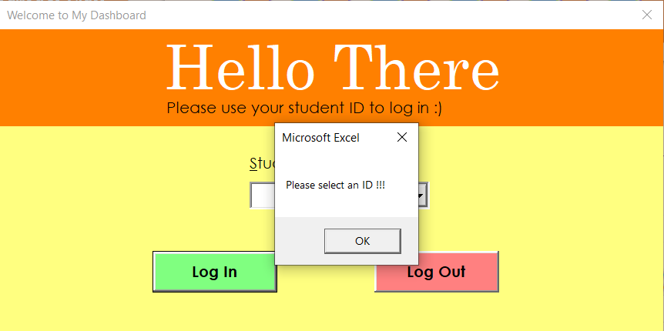Result : Success

## **White Box testing**

White Box “testing based on the internal logic, which is used to design test cases. Correct outputs are still defined by requirements (i.e. specification)”

Test : User can view the comment of the course leader and the grade disruption (1st ,2-2,2-1,3rd)

Expected: Respective cells in the dashboard will fill with the requested values when user selects the wanted student ID

Result: success

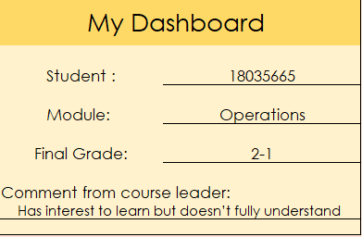

Initial filled cells before test

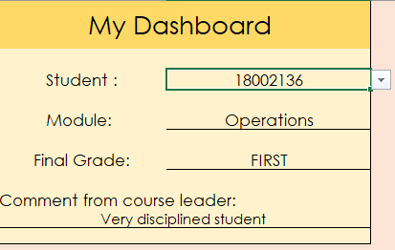

New data in cells as requested by user, after test

## **User Testing**

1. Test UF restrictions:

User tries to close UF to ignore it and enter the dashboard with no validation. Proper reaction: Error message “UF cannot close, please Validate”

Feedback: UF closed and user proceeded to the dashboard.

Result: Failed

Solution: Create code to restrict user from closing the UF unless they have provided a user ID

1. Test adding new ID in selecting the Student ID in the dashboard.

Propper reaction, typed ID matches an already existed ID, value still links to information associated to ID, tables format as usual.

Feedback: Cell function code got replaced with text ID , tables no longer sink or gather data from that cell to format with new data

Result : Fail

Solution: Create search-bar in a cell with drop down list , able to be typed instead of just selecting from list

# References

*Evaluation of Effective Dashboards: Key Concepts and Criteria*. (n.d.). Retrieved from https://www.ncbi.nlm.nih.gov/pmc/articles/PMC5688382/

Few, S. (2006). *Common Pitfalls in Dashboard Design .*

Tufte, E. (1983). *Graphical Integrity.*

Tufte, E. (2001). *The Visual Display of Quantitative Information .* Graphics Press; 2nd edition edition (May 1, 2001).